Kian Gault

Scottish Candidate Number: 090410512  
HND: Software Development

Software REquriements Spesfication

Commissioned by Simply Rugby

Contents

Introduction 2

Purpose: 3

Product Description 4

Project Scope 5

Key Users 6

Functional Requirements 7

1.1 7

1.2 8

1.3 9

1.4 10

1.5 11

1.6 12

Non-Functional Requirements 13

Hardware Requirements 14

Constraints 15

User Interaction / Interface 16

Appendices 17

Appendix 1: 17

Appendix 2: 18

Appendix 3: 19

Appendix 4: 20

Appendix 5: 21

Appendix 6: 22

# Introduction

Welcome to the SRS document for the application commissioned by the Simply Rugby Club. This document is to serve as a concrete guide on the analysis of the application.   
  
This document will cover the need for this application, it’s different set of requirements from functional to non-functional, to security and software requirements.   
  
This document will be a key reference in the final planning report for this project for when analysis is needed this document will provide.

# Purpose:

The purpose of this SRS document is to create a mutual understanding between the development team and the customer on the basic underlining functionality of the product being built.

In this document key areas will be identified such as functional and non-functional requirements and hardware requirements plus any additional information that will serve the developer and client in referencing later in the project.

Each function expected of this application has a unique ID so our OOP Solutions’ testers can trace their work back to this requirements document to ensure this product is delivered at the quality agreed on this SRS.

# Product Description

This application is to create a computerized version of the simply rugby management system. This system is designed to keep track of the clubs’ team’s information.

The two key aspects of the information kept are personal details and profiles that tracks the player’s skill for all the different teams.

Making this system computerized will help the business management side of the club be more organized and up to date with modern technology data holding.

Additionally, this will help the users manage their specific roles more effectively.   
  
The key aspect of this application will be the data storage. The product will use Visual Studios built-in framework for data storage and make use of SQLite. This will allow the data to be updated and saved even after sessions end as this will be an on-going system Simply Rugby will use.

# Project Scope

The overall scope of this project is going to be pretty leaner as the time frame set out is a rather short one. Regardless of the time frame we as a company will always follow an agile methodology software approach.   
  
This means we will be working in ‘sprints’ that allow us to create some product then regularly review this work with the client. This will be a consistent practice over the whole project to make sure Simply Rugby is satisfied with the progress and the end result.

The three main stages of this project will be planning, development and evaluation. These are the key areas of this project that OOP Solutions will ensure we deliver high quality through each phase.

This application will be issued to the client Simply Rugby by no later than May of 2023 and if satisfied with the product Simply Rugby can apply this application to their business instantly.

# Key Users

**The Club’s Administrators:**

One of the key users of this application will be the assigned admins for the club. The main objective the admin will have when accessing this software is to obtain the personal details of the club’s players. Here they can edit and delete the details when needed.

The admin will also have the ability to view and change the skill profiles for every team within in the club.

**The Club’s Coaches:**

The other key user of this application will be the club coaches. The coaches will need access to the player’s skill profiles as they are responsible for tracking their team’s progress.

They will also have access to their team’s personal records. This is due to GDPR so they will have strict access to the personal records database to make sure this is met.

**Owner/Emergency Login:**

This user is more of a backup user in the case the club admin is unavailable. This can be used by the owners of the club or any executive staff member who may need to access the system in an emergency.

This can also be used by any developer that may need to come in post-release to fix any errors that occur for the system.

# Functional Requirements

1.1 The admin uses their login details to  
 access the system. (Appendix #1)

1.1.1 The admin enters their username.

*Description – The admin enters the username giving to   
 them by the company. This is their own   
 personal ID that gives them admin privileges.  
 Constraints – The username entered must be at least 9   
 characters.*

1.1.2 The admin enters their password.

*Description – The admin enters the password given to   
 them by the company. This is their own   
 personal ID that gives them admin privileges.  
 Constraints – The password entered must be at least 9   
 characters.*

*1.1.3* The admin clicks submit login button.

*Description – Once the admin has entered both their   
 username and password they will submit this   
 in which the system will check.  
 Constraints – The system will check that the username   
 and password match an already stored login   
 for the system. If it matches, then the admin   
 will be directed to admin hub.*

1.2 The coach uses their login details to access   
 the system (Appendix #3)

*1.2.1* The coach enters their username.

*Description – The coach enters the username giving to   
 them by the company. This is their own   
 personal ID that gives them access to the   
 system.  
 Constraints – The username entered must be at least 9   
 characters.*

1.2.2 The coach enters their password.

*Description – The coach enters the password given to   
 them by the company.   
 Constraints – The password entered must be at least 9   
 characters.*

*1.2.3 The coach clicks on the submit login button.*

*Description – Once the coach has entered both their   
 username and password they will submit this   
 in which the system will check.  
 Constraints – The system will check that the username   
 and password match an already stored login   
 for the system. If it matches, then the coach   
 will be directed to the coaches hub.*

1.3 Admin wants to edit/add/delete records for the player database.  
 (Appendix #5)

1.3.1 Adding/editing/deleting the player’s name

*Description – The admin enters the player’s given name to the database.  
 Constraints – The textbox will need a minimum of 1 letter and a maximum of 15 letters.*

*1.3.2* Adding/editing/deleting the player’s age

*Description – The admin enters the player’s age.  
 Constraints – The admin must enter a numerical value to   
 the textbox.*

*1.3.3* Adding/editing/deleting a player’s e-mail

*Description – The admin enters the player’s assigned E- mail address.  
 Constraints – The e-mail address must contain the standard set of e-mail characters.*

*1.3.4* Adding/editing/deleting the player’s Scottish Rugby Union   
 Number

*Description – The admin enters the player’s giving SRU number. This value must be unique as it’s the   
 key.  
 Constraints – The number entered must be numeric and be at least 9 characters.*

*1.3.5* Adding/editing/deleting the player’s contact number (Or   
 parent contact number if it’s a junior team player)

*Description – The admin enters the player’s set contact number.  
 Constraints – The number entered must be numeric and be at least 9 characters.*

*1.3.6 Adding*/editing/deleting *parent consent for a junior team   
 player*

*Description – The admin enters the details of the parent*

*writing the consent form and if the consent*

*is given*

*Constraints – We will the text in the consent given or not #*

*box to a yes or no condition.*

*1.3.7 Adding*/editing/deleting *the players Shoe Size*

*Description – The admin enters the size of shoe for the*

*player.  
 Constraints – The input must be numeric.*

*1.3.8 Adding the player’s number of years at the club.*

*Description – The admin enters the number of years the*

*player has been at the club..  
 Constraints – The input must be numeric.*

1.4 Admin decides to search for specific player information (Appendix #2)

*1.4.1 The admin selects the team they wish to view*

*Description – The admin will be presented with the list of   
 teams and they must select what team’s   
 details they want to start editing.   
 Constraints – Must click on the button with the name of the   
 team they wish to edit.*

*1.4.2 The admin accesses the search box and enter the desired   
 player’s SRU number.*

*Description – The admin must enter a number that matches   
 a stored player’s SRU number as this will be   
 our key field within the database.   
 Constraints – The value must be numeric.*

*1.4.3 The admin wishes to delete the record*

*Description – The admin selects the player they wish to   
 delete and presses the button called delete.  
 Constraints – The admin can’t delete a record that does not   
 exist.*

1.5 The coach wants to edit the player skill profiles for   
 their team. (Appendix 4)

*1.5.1 The coach amends the passing category*

*Description – The coach accesses the passing section of the   
 skill form. Here they can add/edit a skill   
 rating for standard, spin and pop skills.   
 Constraints – The skill rating must be from 1 to 5*

*1.5.2 The coach amends the tackling category*

*Description – The coach accesses the tackling section of   
 the skill form. Here they can add/edit a skill   
 rating for front, rear, side scrabble skills.  
 Constraints – The skill rating must be from 1 to 5*

*1.5.3 The coach amends the kicking category*

*Description – The coach accesses the kicking section of the   
 skill form. Here they can add/edit a skill   
 rating for drop, punt, grubber and goal skills.  
 Constraints – The skill rating must be from 1 to 5*

*1.5.4 The coach searches for a specific player profile in their   
 team.*

*Description – The coach enters the SRU number for   
 the player they wish to find. They then   
 have the option to edit or delete this   
 profile.   
Constraints – SRU number must be numeric and   
 match an existing player record. The   
 record must also be on their team.*

1.6 The coach wants to view their team’s personal records. (Appendix 6)

*1.6.1 The coach presses the button on the coach hub to   
 access the personal records of their team.*

*Description – When in the coach hub window, the   
 coach will press on the button labelled   
 personal records which will take the   
 coach to the window.   
Constraints – The coach must only get access to the   
 records of their team. This is because   
 GDPR is in effect.*

*1.6.2 The coach enters a player SRU number to search for   
 a specific player record on their team.*

*Description – The coach enters the SRU number for   
 the player they wish to view.   
Constraints – The SRU number must be numeric and   
 match an existing entry on the   
 database.*

# Non-Functional Requirements

**Security:**

This application will deal with personal information so the General Data Protection Regulation will need to be advised.

The main way we can achieve this is through passwords so anyone who may try and access a piece of the system they should not be will be blocked out.

This is crucial as the coaches are sometimes parents so they can’t have access to the areas of information the administrators have.

**Performance:**

This application will be designed and made with a Windows Presentation Foundation application.

This is the chosen type of software as it will work seamlessly with most modern computerized systems.

**Maintainability:**

Because this is a WPF application this will make it easier for the developers to access the application if needed is any errors occur in this application.

# Hardware Requirements

Since this application is a server-based application a PC with internet connection will be needed to access the system.

We as a company have been tasked to purchase new equipment for this system to work on. The budget for this is £600.   
  
Monitor:   
  


Source: [Buy HP 22m Full HD 21.5" IPS LCD Monitor - Black | Currys](https://www.currys.co.uk/products/hp-22m-full-hd-21.5-ips-lcd-monitor-black-10244396.html)

Desktop:



Source: [Buy ACER Aspire XC-840 Desktop PC - Intel® Celeron®, 256 GB SDD, Black | Currys](https://www.currys.co.uk/products/acer-aspire-xc840-desktop-pc-intel-celeron-256-gb-sdd-black-10243343.html)

Total Hardware Costs: £336

# Constraints

1. Must remain within the given budget.
2. An Internet connection will be needed for the application to run.
3. Since the application relies on an external database synching issues could be a possibility.
4. This application will be designed using a Microsoft development environment so compatibility with other operating systems could be challenging.
5. We have a short time frame to create this application as Simply Rugby needs this application made soon.
6. The size of the OOP solutions team is small so any future updates might be slow.

# User Interaction / Interface

* This application will be presented in a windows format.
* The main user interaction will be through entering text, hitting buttons and pressing the enter key
* This application will allow users to enter information and that information will then be saved externally.
* The user interface will be designed in a clear and easy to navigate way to make user experience straightforward.

# Appendices

## Appendix 1:

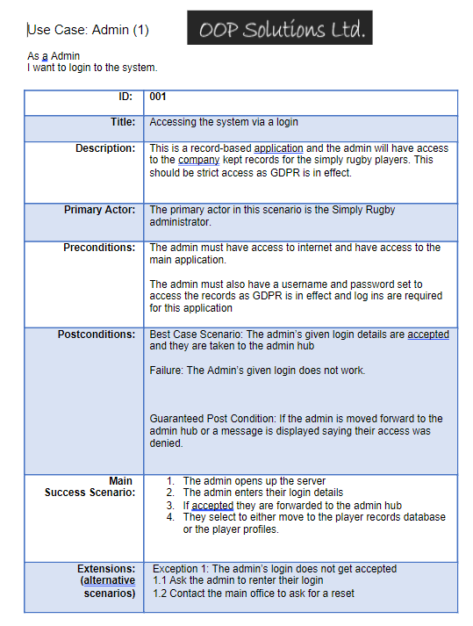

## Appendix 2:

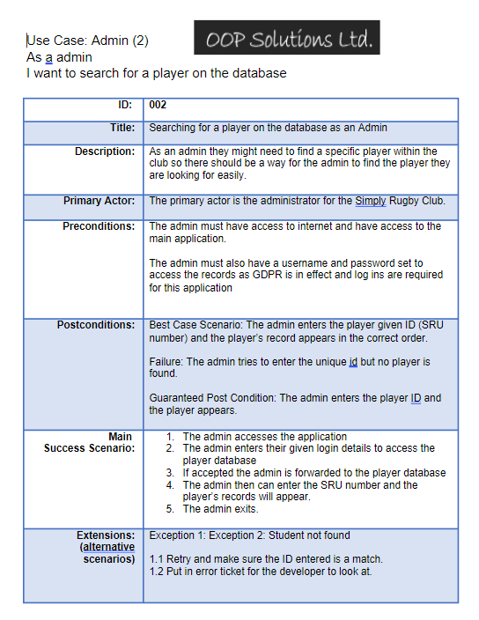

## Appendix 3:

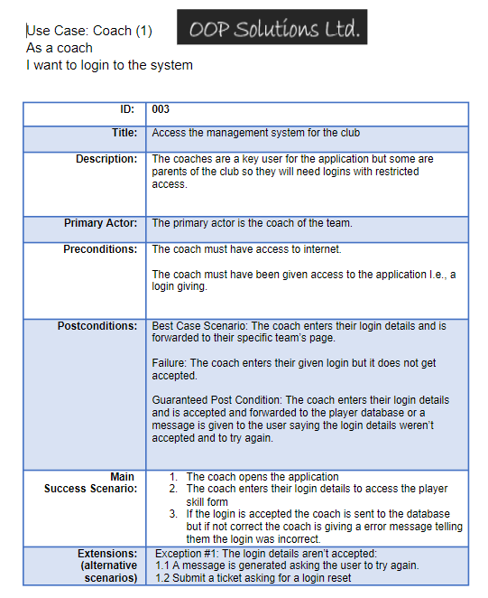

## Appendix 4:

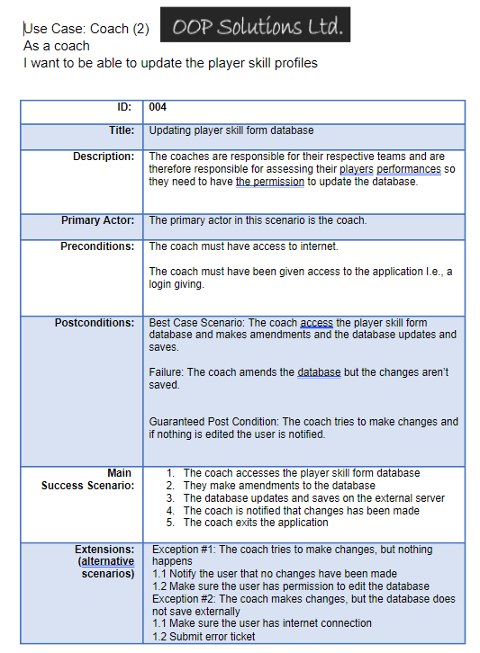

## Appendix 5:

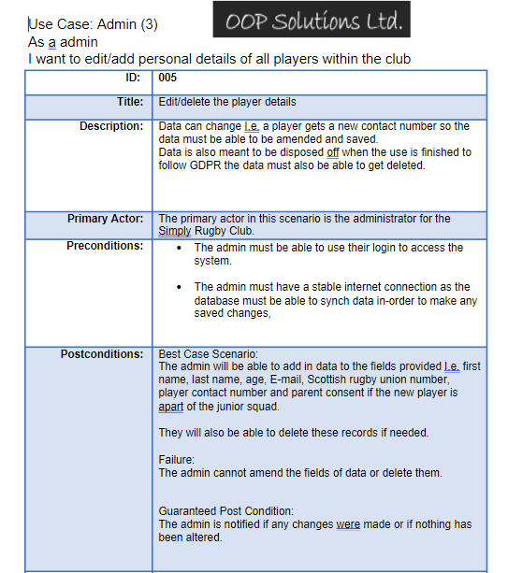

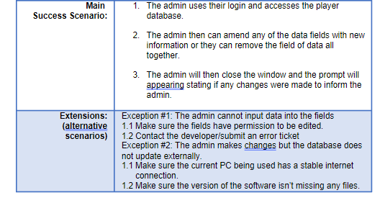

## Appendix 6:

